**23CSE111**

**OBJECT ORIENTED PROGRAMMING**

**LAB REPORT**



**Department of Computer Science Engineering**   **Amrita School of Computing**

**Amrita Vishwa Vidyapeetham, Amaravati Campus**

**Name: Keerthi Vardhan Anugutala**

**Roll No: 24241**

**Verified By :**

|  |  |  |  |  |
| --- | --- | --- | --- | --- |
| **S.NO** | **Experiment** | **Page No** | **Remarks** | **Signature** |
| **1** | **Installation Process of JDK** | **3-4** |  |  |
| **2** | **Simple java program for printing basic details of student** | **5** |  |  |
|  |  |  |  |  |
|  |  |  |  |  |

**INDEX**

# WEEK-1

1. **Process of Installing JDK (Java Development Kit)**

**Installing JDK (Java Development Kit):**

* 1. **Download JDK:**
* Go to the Oracle JDK download page in google and click on JDK-21 version which is Long term support (LTS) version.
* Click the download link as your operating system (Windows, macOS, or Linux).
  1. **Install JDK:**
* Once downloaded, run the installer.
* Follow the given instructions and keep clicking "Next" until it is done.
  1. **Set Environment Variables (Windows):**
* Open file explorer, then right click on This PC next select on properties then it will take you to the settings app then click on advanced system settings and then click on **Environment Variables**.
* Click on path and new under **System Variables**:

**Variable value:** The folder address where JDK is installed (like

C:\Program Files\Java\jdk-21\bin)

* Find Path under **System Variables**, click **New**, and add the path of the jdk-21(C:\Program Files\Java\jdk-21\bin)

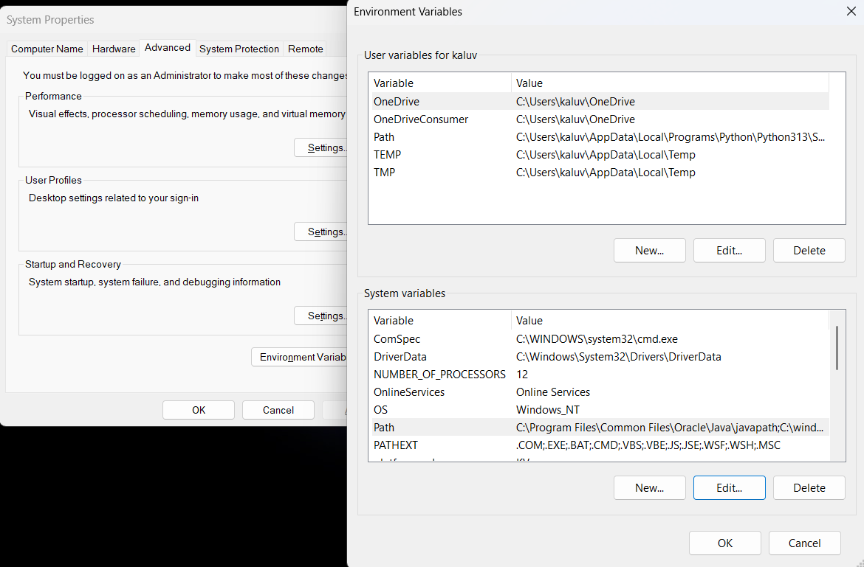

**Checking JDK Version: -**

* 1. **Open Command Prompt:**
* Presswin+R, typecmd, and press Enter.
  1. **Check Version:**
* Type java -version and press Enter.
* Type javac --version and press Enter.

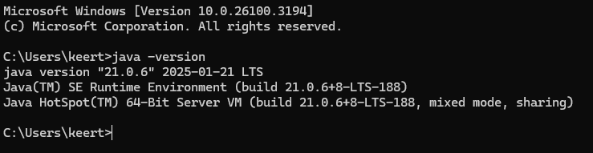

1. **Simple Java Program for printing Name, Class, Roll No, of a Student**

Write your code in Notepad and execute it in cmd prompt

**CODE: -**

class Main

{

public static void main(String[] args)

{

System.out.println("Name: Keerthi Vardhan");

System.out.println("Class:CSE-C");

System.out.println("Roll No:24204");

}

}

**Output: -**

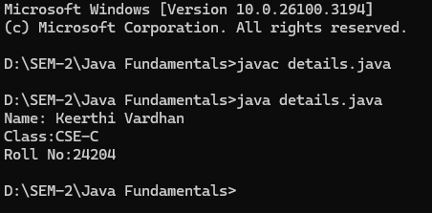

|  |  |  |
| --- | --- | --- |
| 1 | Syntax error | Semicolon added |
| 2 | Runtime error | Copied correct path |
| 3 | Name error | rectified |

1. **Simple Java Program for finding simple interest by taking input from**

**User**

**Code:**

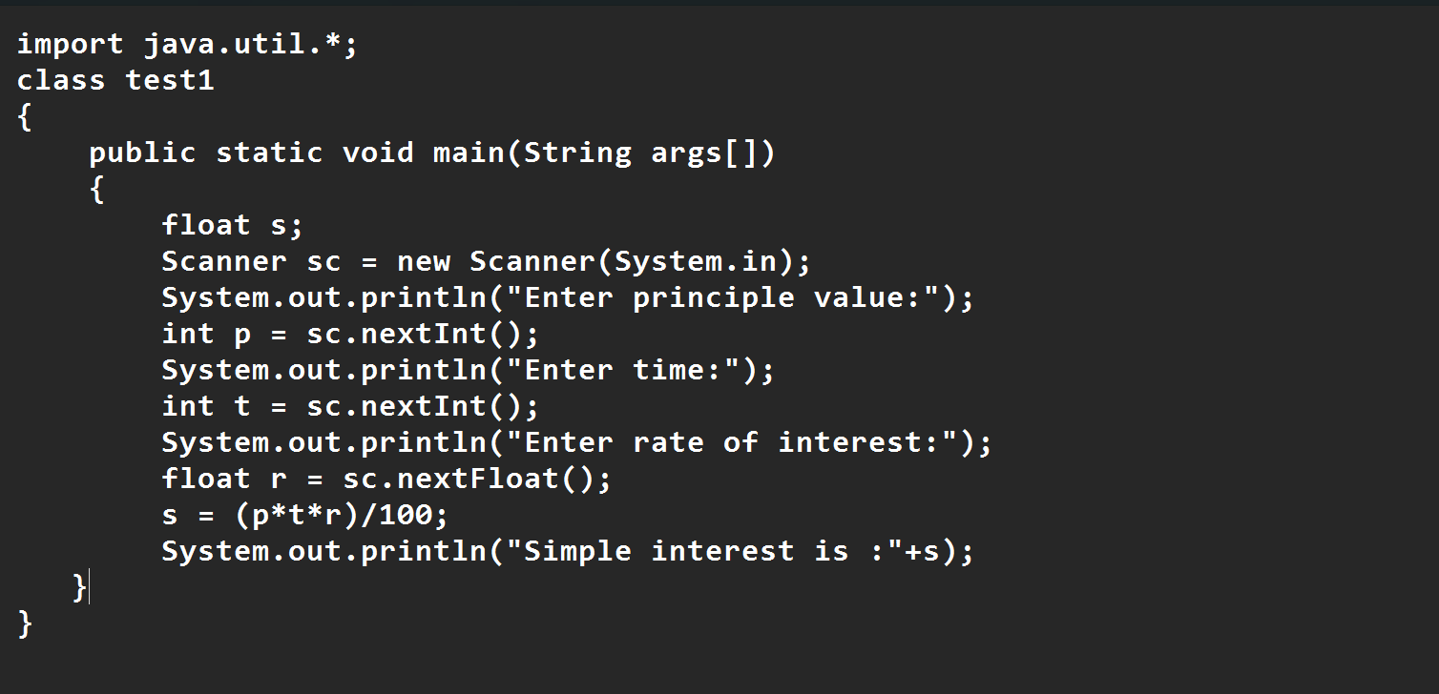

**Output**

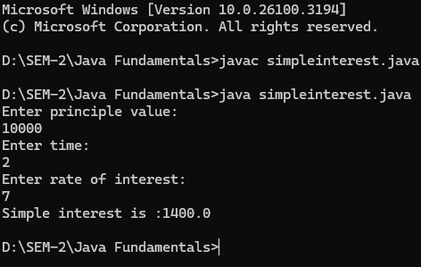

|  |  |  |  |
| --- | --- | --- | --- |
| **S.No** | **Error type** | **Reason for error** | **rectification** |
| **1** | **Runtime error** | **Incorrect path** | **Copied correct path** |
| **2** | **Syntax error** | **{ missing** | **{ added** |
| **3** | **Logical error** | **Wrong formula** | **Formula rectified** |

**2.Write a simple program to calculate factorial of a number and read the**

**input from user**

**code:**

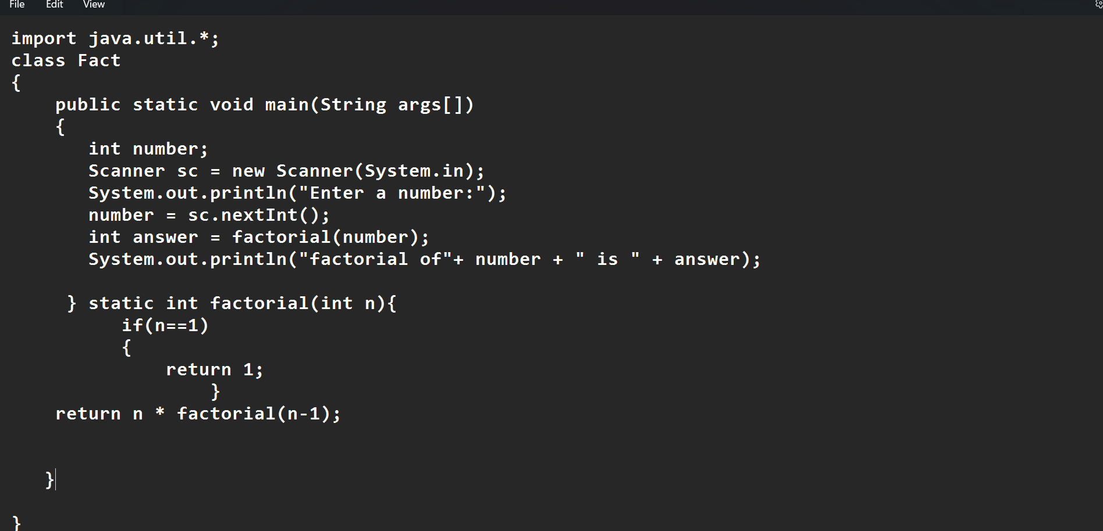

**Output:**

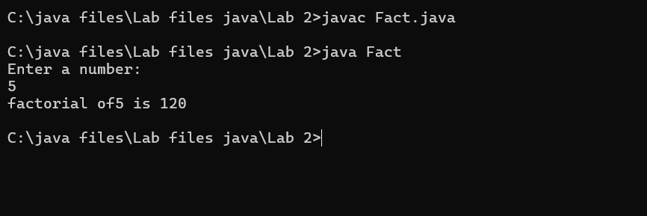

|  |  |  |  |
| --- | --- | --- | --- |
| **S.No** | **Error type** | **Reason for error** | **Rectification** |
| **1** | **Undeclared variable error** | **Missing variable** | **Variable declared** |
| **2** | **Missing import statement** | **Not importing packages** | **Packages imported** |
| **3** | **Logical error** | **Wrong formula** | **Formula rectified** |

**3.Write a program to to calculate the fibonacii sequence and take the input from user**

**Code:**

**import java.util.*;**

**class fibo**

**{**

**public static void main(String args[])**

**{**

**Scanner sc = new Scanner(System.in);**

**int num;**

**int f3;**

**int f1 = 0;**

**int f2 = 1;**

**int i = 2;**

**System.out.print("Enter a number:");**

**num = sc.nextInt();**

**System.out.println(f1);**

**System.out.println(f2);**

**while(i<num)**

**{**

**f3 = f1+f2;**

**f1 = f2;**

**f2 = f3;**

**System.out.println(f3);**

**i = i+1;**

**}**

**}**

**}**

**Output:**

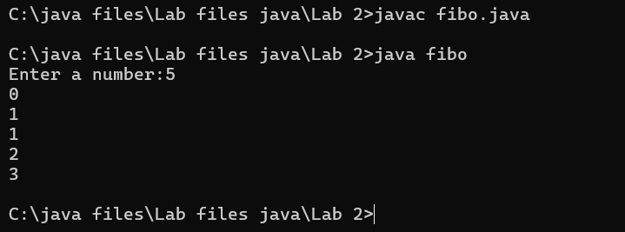

|  |  |  |  |
| --- | --- | --- | --- |
| **S.No** | **Error type** | **Reason for error** | **Rectification** |
| **1** | **Logical error** | **Incorrect formula** | **Formula rectified** |
| **2** | **Run-time error** | **Incorrect path** | **Added correct path** |
| **3** |  |  |  |

**Write a java program to convert temperature from Fahrenheit to celsius**

**Code:**

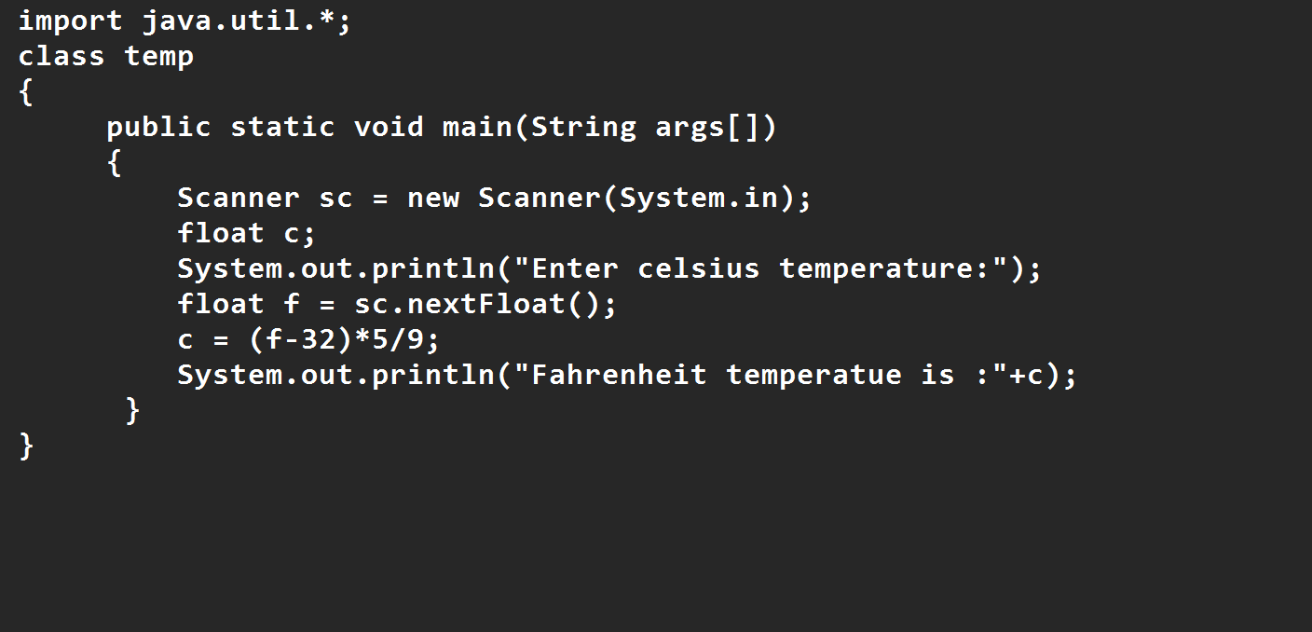

**Output:**

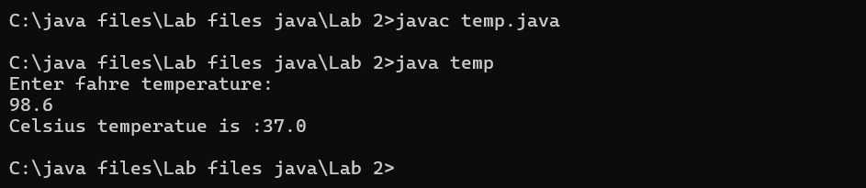

|  |  |  |  |
| --- | --- | --- | --- |
| **S.No** | **Error type** | **Reason for error** | **rectification** |
| **1** | **Syntax error** | **Missing ”** | **“ is added** |
| **2** | **Missing import error** | **Util package missing** | **Util package added** |
| **3** |  |  |  |

* 1. **Write a java program to convert temperature from Celsius to Fahrenheit**

**Code**

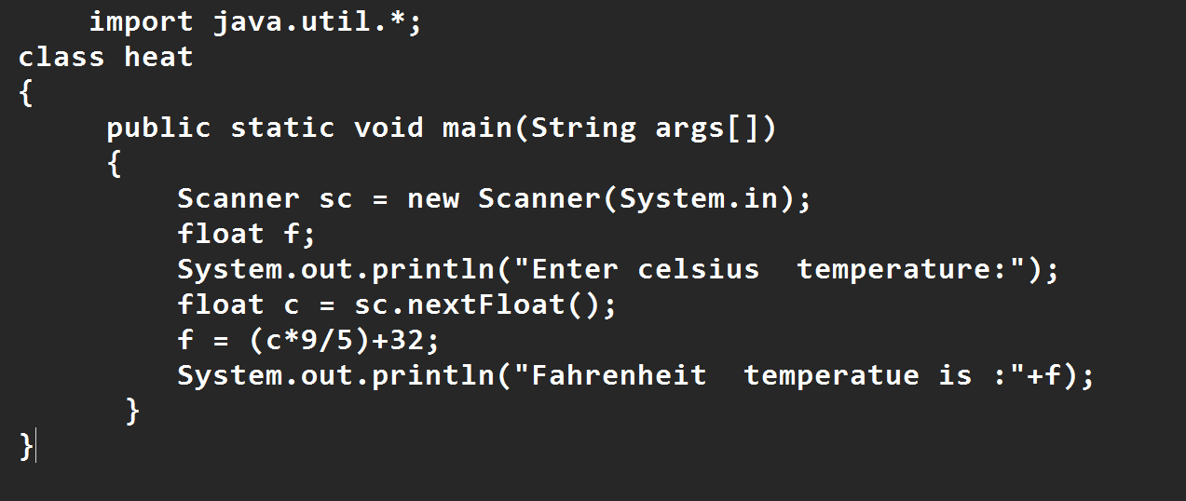

**Output:**

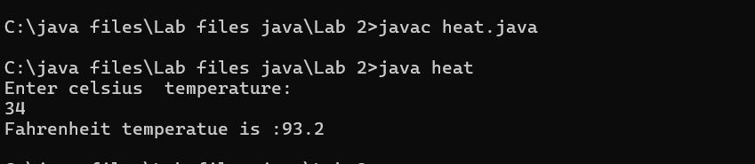

|  |  |  |  |
| --- | --- | --- | --- |
| **S.No** | **Error type** | **Reason for error** | **Rectification** |
| **1** | **Runtime error** | **Incorrect path selection** | **Correct path added** |
| **2** | **Logical error** | **Incorrect logic** | **Correct logic** |
| **3** |  |  |  |

**Write a simple program to find the area of rectangle:**

**Code:**

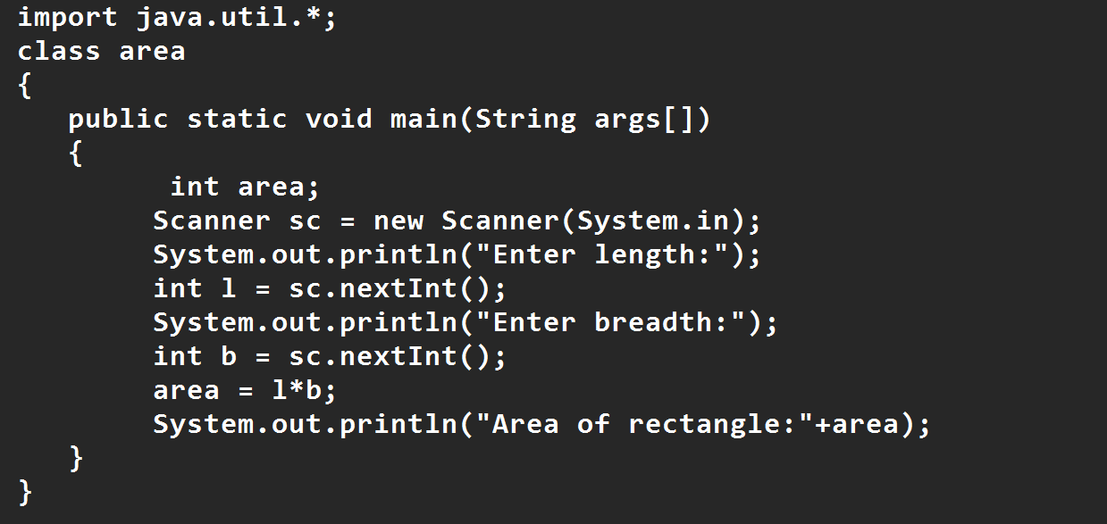

**Output:**

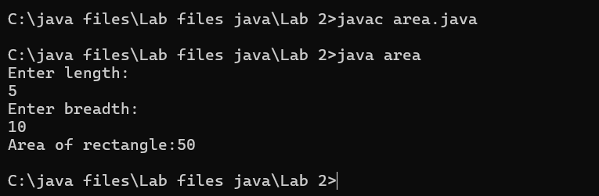

|  |  |  |  |
| --- | --- | --- | --- |
| **S.No** | **Error type** | **Reason for error** | **Rectification** |
| **1** | **Syntax error** | **Semi colon missing** | **Semi colon added** |
| **2** | **Missing import error** | **Import package missing** | **Import package added** |
| **3** |  |  |  |

**Write a program to find the area of triangle by using heron’s formula take the input from the user**

**Code:**

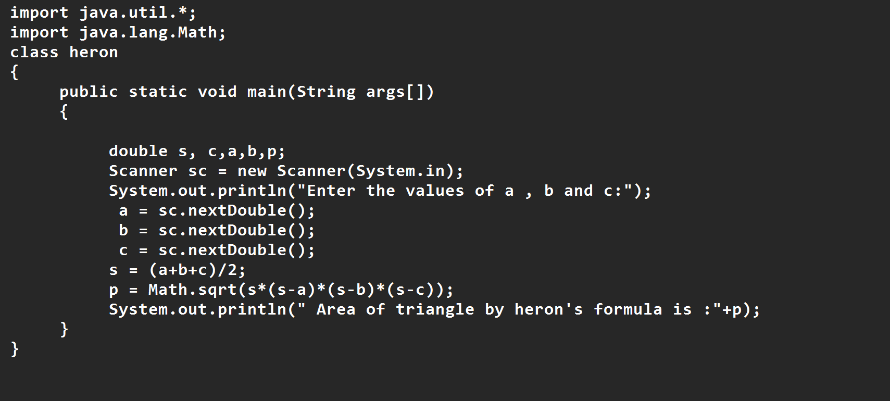

**OUTPUT:**

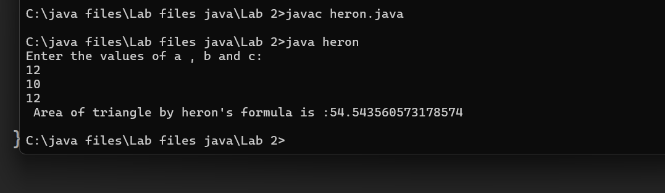

|  |  |  |  |
| --- | --- | --- | --- |
| **S.No** | **Error type** | **Reason for error** | **Rectification** |
| **1** | **Logical error** | **Incorrect formula** | **Formula rectified** |
| **2** | **Name error** | **Undeclared variable** | **Variable declared** |
|  |  |  |  |

**WEEK 3**

**Aim:**

**To create java program with following instructions**

**1.Create a class with name car**

**2. Create four attributes named car_color ,Car_brand,fuel_type,mileage**

**3. Create three methods named start(), stop(). Service()**

**4. Create three objects named car1,car2 and car3**

**Code:**

**import java.util.*;**

**class car**

**{**

**public String Car_color;**

**public String Car_brand;**

**public String fuel_type;**

**public int mileage;**

**public void start()**

**{**

**System.out.println("Car Started:");**

**System.out.println("Car color is :"+Car_color);**

**System.out.println("Car Brand is:"+Car_brand);**

**System.out.println("Car fuel type is:"+fuel_type);**

**System.out.println("Car mileage is:"+mileage);**

**}**

**public void service()**

**{**

**System.out.println("Car Started:");**

**System.out.println("Car color is :"+Car_color);**

**System.out.println("Car Brand is:"+Car_brand);**

**System.out.println("Car fuel type is:"+fuel_type);**

**System.out.println("Car mileage is:"+mileage);**

**}**

**public void stop()**

**{**

**System.out.println("Car Started:");**

**System.out.println("Car color is :"+Car_color);**

**System.out.println("Car Brand is:"+Car_brand);**

**System.out.println("Car fuel type is:"+fuel_type);**

**System.out.println("Car mileage is:"+mileage);**

**}**

**public static void main(String args[])**

**{ System.out.println("\n manoj\n\n");**

**car car1 = new car();**

**car1.Car_color = "Blue";**

**car1.Car_brand = “Skyline";**

**car1.fuel_type = "Deisel";**

**car1.mileage = 10;**

**car1.start();**

**car car2 = new car();**

**car2.Car_color = "Red";**

**car2.Car_brand = "AMG";**

**car2.fuel_type = "Diesel";**

**car2.mileage = 30;**

**car2.stop();**

**car car3 = new car();**

**car3.Car_color = "Yellow";**

**car3.Car_brand = "BMW";**

**car3.fuel_type = "Petrol";**

**car3.mileage = 20;**

**car3.service();**

**}**

**}**

**Output:**

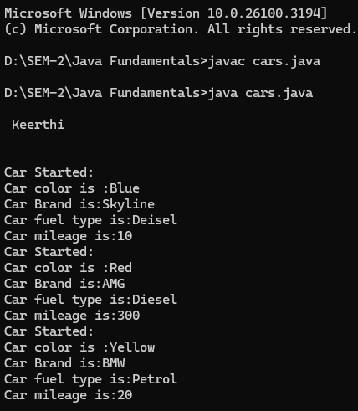

**2. To create a class bankAccount with methods deposit() and withdrawl**

**Code:**

**class BankAccount**

**{**

**private double balance;**

**public BankAccount(double initialBalance)**

**{**

**if(initialBalance > 0)**

**{**

**this.balance = initialBalance;**

**}**

**else**

**{**

**this.balance = 0;**

**}**

**}**

**public void deposit(double amount)**

**{**

**if(amount>0)**

**{**

**balance = balance+amount;**

**System.out.println("Deposited £:"+amount);**

**}**

**else**

**{**

**System.out.println("Deposited amount must be positive");**

**}**

**}**

**public double getBalance()**

**{**

**return balance;**

**}**

**}**

**public class Main1**

**{**

**public static void main(String args[])**

**{**

**BankAccount account = new BankAccount(1000);**

**account.deposit(500);**

**System.out.println("Current Balance is:"+account.getBalance());**

**}**

**}**

**Output:**

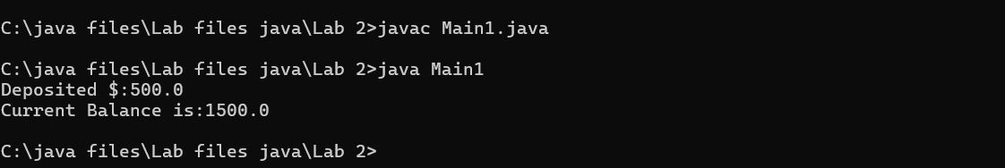

WEEK -4

PROGRAM – 1:

AIM: Write a java program with class named “book”, the class should contain various attributes such as title, author, year of publication it should also contain a constructor with parameters which initializes, title, author, and year of publication.

Create a method which displays the details of the book and display the details of two books.

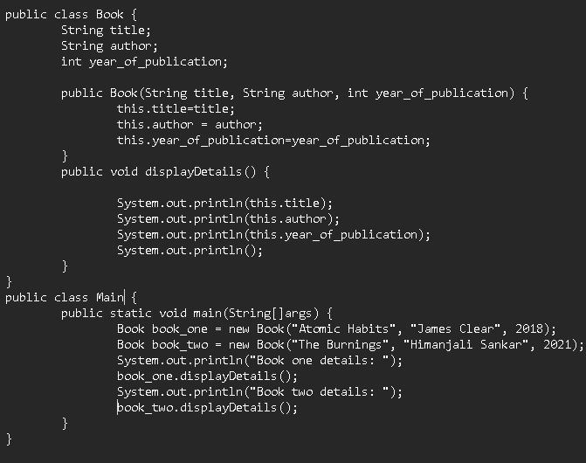

OUTPUT:

Book one details:

Atomic Habits-James clear-2018

Book two details:

The burnings-Himanjili Sankar-2021

|  |  |
| --- | --- |
| **Code Error** | **Code rectification** |
| 1. Not defining the function in a file. 2. Two public class files should not be saved in the same file. | 1. To call the method we must define a function in a file. 2. Two public class files should be saved in different files. |

IMPORTANT POINTS:

1. While defining two classes for a code, we must be sure that we save both the classes in separate files.
2. While defining a method we should also define a function to call that method.

CLASS DIAGRAM:

|  |
| --- |
| Book   * Title: String * Author: String * Year of publication: int   + Book(title: String,  Author: String;  Year of publication: int  + displayDetails( ): void |

PROGRAM – 2:

AIM: Create a java Program with class named myclass with static variable count of int type, initialized to zero and a constant variable “pi” of type double initialized to 3.14 as attributes of the class, ow define a constructor for “myclass” that increments the count variable each time an object of my class is created (count++), finally print the final values of count and pi variables create three objects.

CODE:

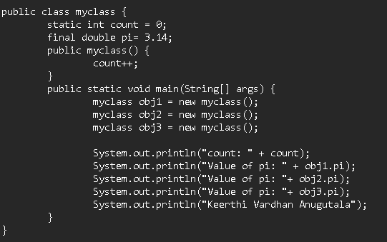

OUTPUT:

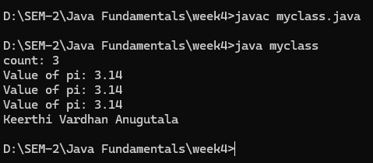

ERROR TABLE:

|  |  |
| --- | --- |
| **Code Error** | **Code rectification** |
| 1. Not Putting the semi-colon after calling a function, 2. Not giving the indentation properly. | 1. Put the semi-colon after calling a function. 2. All the indentation must be correct to run the code correct. |

IMPORTANT POINTS:

1. We must declare the initial value of the variable before declaring the final one.
2. Here the main objective is to increase the count according to the number of objects we make, i.e the count increases when the no.of objects are increasing.

CLASS DIAGRAM:

|  |
| --- |
| Myclass   * Count: int * Pi: double   + myclass( )  + main(args: String[]): void |